**Experiment No. 01**

* 1. **Experiment Name**

Introduction to PLC Ladder Diagram in Siemens LOGO! Soft Comfort Platform & OMRON CP1E 40 I/O PLC Trainer Kit

* 1. **Objectives**
* To get a better understanding of PLC hardware and Ladder diagram
* To get familiar with the design and simulation procedure of PLC in LOGO! Soft Comfort Platform
* To get familiar with the procedure of PLC trainer kit OMRON CP1E 40 I/O
  1. **Apparatus**
* LOGO! Soft Comfort Platform
* OMRON CP1E 40 I/O
  1. **Theory**
     1. **Programmable logic controller (PLC)**

Programmable logic controller (PLC) is specialized computerized device commonly used in industrial automation system. They are used to control and monitor various process and machinery. They were originally modified from relay logic, as troubleshooting and maintenance was challenging in relay logic.

PLC consists of components like input module, output module, CPU, memory, power supply, programming device, and communication interface.

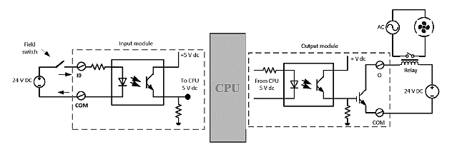

**Figure 1.1:** Input module & output module internal connection (sink type)

PLC can be displayed by hardware and ladder diagram. This ladder diagram contains positive and negative power rail along with rung, and rung inputs and outputs. Here the power flow direction of the ladder diagram is from left to right and top to bottom. Moreover, the input or output coils may be closed or open contacts.

* + 1. **OMRON CP1E 40 I/O trainer kit**

The OMRON CP1E 40 I/O is a PLC trainer kit that supports both sink type and source type PLC connections. The are multiple channels on the input or output side. The input and output ports are respectively defined as X and Y.

These ports are identified as following format, X.0.02 where this identifies as the input from port 2 of channel 0. In the same way, Y.100.03 identifies as output to port 3 of channel 100. The inputs are not grouped but the outputs are grouped. As external devices, there are lamp, motor and a buzzer. The PLC is connected to the computer by ethernet cable. There is an internal power supply unit for the PLC.

* 1. **Problem and necessary diagram**
     1. **Problem 1**

**Input:** One start push button (normally open)

**Output:** Induction motor

**Operation:** The push button is pressed, the motor starts. Push button is released, remains running

**Hardware diagram:**

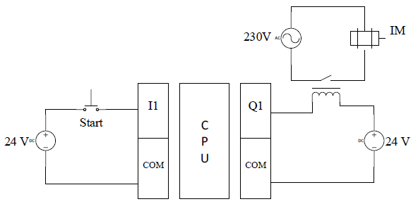

**Figure 1.2:** Hardware diagram for problem 1.5.1

**Ladder diagram:**

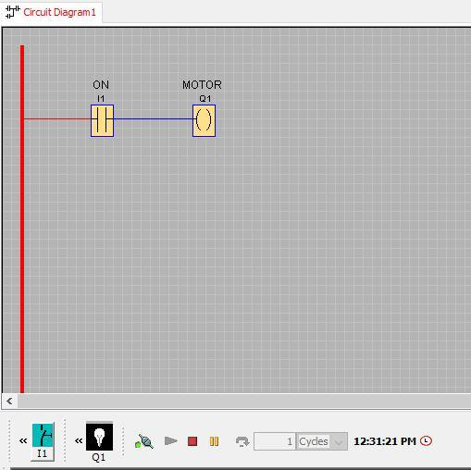

**Figure 1.3:** Ladder Diagram of problem 1.5.1

* + 1. **Problem 2**

**Input:** One start push button (normally open) for clockwise rotation,

One start push button (normally open) for anti-clockwise rotation

One stop push button (normally open)

**Output:** Induction motor

**Operation:**

*The clockwise start button is pressed; the motor rotates clockwise.

*The anti-clockwise start button is pressed; the motor rotates anti-clockwise

*The stop button is pressed, the motor stops

*During clockwise rotation, anti-clockwise rotation circuit will be inactive and vice-versa

**Hardware diagram:**

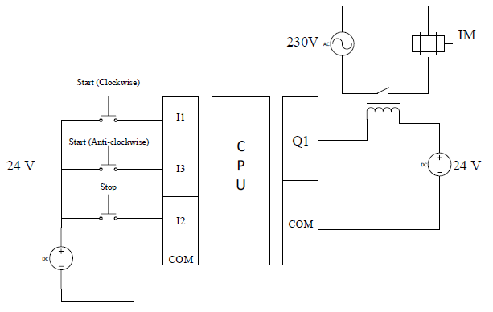

**Figure 1.4:** Hardware diagram for problem 1.5.2

**Ladder diagram:**

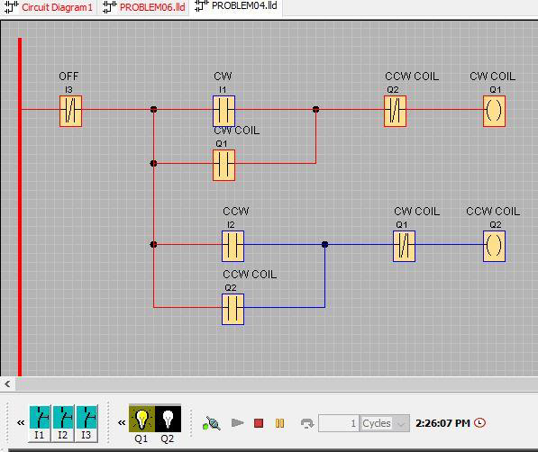

**Figure 1.5:** Ladder Diagram of problem 1.5.2

* + 1. **Problem 3**

**Input:** One start push button (normally open) for clockwise rotation,

One start push button (normally open) for anti-clockwise rotation

One stop push button (normally open)

**Output:** Induction motor

**Operation:**

**\***The clockwise start button is pressed; the motor rotates clockwise.

*The anti-clockwise start button is pressed; the motor rotates anti-clockwise

*The stop button is pressed, the motor stops

*During clockwise rotation, anti-clockwise rotation circuit will be inactive and vice-versa

**Hardware diagram:**



**Figure 1.6:** Hardware diagram for problem 1.5.3

**Ladder diagram:**

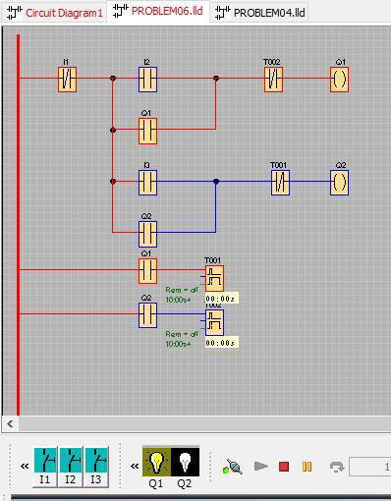

**Figure 1.7:** Ladder Diagram of problem 1.5.3

* 1. **Hardware connection to OMRON CP1E 40 I/O**

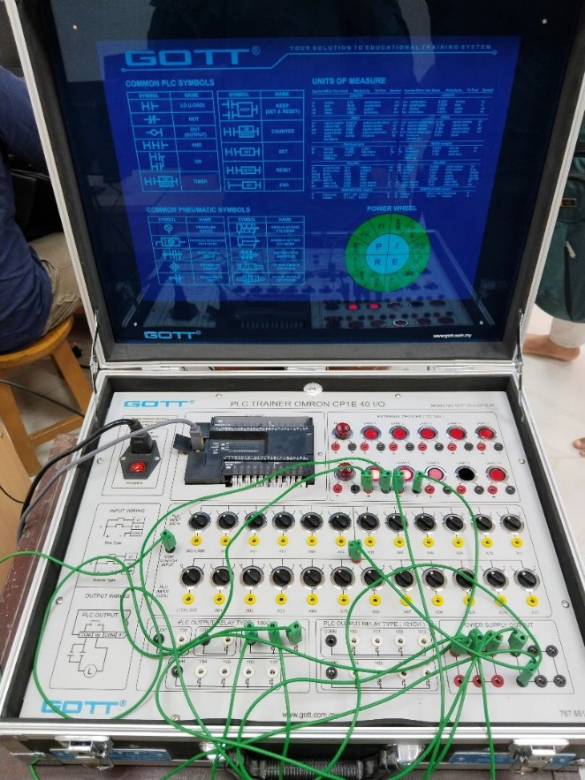

**Figure 1.8:** Experimental setup of OMRON CP1E 40 I/O

* 1. **Discussion & Conclusion**

In this experiment, we designed, implemented, and observed various practical problem. Among them problem 1.5.1, when NO push button is pressed the output is in ON state. In problem 1.5.2 and 1.5.3, the system was quite practical and the concept of interlocking was introduced. Interlocking means the state of one output will affect the other outputs. Here, as the motor was run in clockwise direction it wouldn’t start in anti-clockwise direction. To turn it in anti-clockwise direction it’s required to turn off the motor first.

In reality, if the motor was stopped from clockwise motion, it would not be able to instantly start its anti-clockwise motion because of its inertia. So, there should be some time gap between the stop and start. The time gap was provided by the timer block. Two OFF delay timers of 10 second count were used here. OFF delay timer would follow the rising edge instantly and start the timing action with the falling edge of the timer input signal.

Later on, these were implemented in the PLC trainer kit OMRON CP1E 40 I/O and the results were observed.